**ARP 2024-5**

**Ethical Action Plan**

**Name of practitioner-researcher:** eilis searson

|  |
| --- |
| 1. **What is your project focus?**   I would like to utilise the action research project to facilitate a deeper understanding [in the students] of the role of the self in illustration practice, and a deeper understanding [in both the students and staff] of the individuals who make up the learning community, and how our understanding of diversity and collectivity within the learning community might affect our future illustration practice. In writing and delivering a new project for Level 4 students, I will be utilising the research question:  *How can creative methods be used to examine, interpret, and describe socio-cultural narratives?[1]*  I would like for the project content to address individual selfhood directly, but also to consider and be open to socio-cultural influence and audience outside of the self[2] — it is with this in mind that the Level 4 project focus will be on the concept of how individual ‘taste’ (rather than only selfhood) is constructed in illustration practice, and what it means to share certain elements of ourselves through our ‘taste’, within the learning community and beyond. |
| 1. **What are you going to read about?**   The role of socio-cultural narrative in the art school, autoethnography, inclusive pedagogies, critical race theory, intersectionality, theory on capitalism and its social effects, and more… I will utilise my bibliography from the I.P. unit and expand it accordingly.  **Initial reading on methodologies:**   * Autoethnography, Personal Narrative, Reflexivity: Researcher as Subject, in N. K. Denzin & Y. S. Lincoln (Eds.), Handbook of Qualitative Research (2nd Ed.), Sage Publications * Bochner, A.P. (1997) ‘It’s About time: Narrative and the divided self’, Qualitative Inquiry * Fauchon, M. & Gannon, R. (2020) Illustration Research Methods, Bloomsbury Publishing   **Initial research related to the project topic:**  Books:   * Stephen Bayley (2017) *Taste: The Secret Meaning of Things*, Expanded Edition, Circa Press * Zsofia Kollar (2021) *Object-Oriented Identity: Cultural Belongings from our Recent Past*, Art Paper Editions * Gillian Rose (2001) *Visual Methodologies,* Sage Books  Available at: <https://ebookcentral.proquest.com/lib/ual/detail.action?docID=254742> [Last Accessed September 2024 with UAL Log-in] * Kwame Anthony Appiah (2018) *The Lies That Bind: Re-thinking Identity,* Profile Books  Available at: <https://www-vlebooks-com.arts.idm.oclc.org/Product/Index/1756211?page=0&startBookmarkId=-1> [Last Accessed September 2024 with UAL Log-in] * Virginia Postrel (2003) *The Substance of Style: How the Rise of Aesthetic Value is Remaking Commerce, Culture and Consciousness,* Harper Collins Books * Jonny Banger (2023) *Sports Banger: Lifestyles of the Poor, Rich & Famous,* Thames & Hudson   Zines:    * Audre Lorde (Date unknown) *The Audre Lorde Questionnaire to Oneself*, LCC Zines Collection, Folder 81 * Jan Descartes, Ethan Heitner and Monica McKelvey Johnson (2016) *Our comics, ourselves: identity, expression, and representation in comic art,* LCC Zines Collection, Folder 84 * Emma Warren (2020) *Document Your Cutlure: A Manual,* Sweet Machine Publishing, LCC Zines Collection   Lectures/Broadcasts:     * Shades of Noir (2016) *Beyond Gender: The Identity of Fashion,* LCC Zines Collection, Folder 21  Available at: <https://www.youtube.com/watch?v=t69z-sFCEKs> [Last Accessed September 2024] * Stuart Hall (1997) *Representation and Media*  Available at: <https://www.kanopy.com/en/arts/video/41580> [Last Accessed September 2024 with UAL Log-in] * Stuart Hall (2021) *Through the Prism of an Intellectual Life*  Available at: <https://www.kanopy.com/en/arts/video/11159831> [Last Accessed September 2024 with UAL Log-in] * Adam Curtis *The Century of the Self: 3. There is a Policeman Inside All Our Heads; He Must Be Destroyed* (2002)  Available at: BBC iplayer or Box of Broadcasts <https://learningonscreen.ac.uk/ondemand/index.php/prog/00180FD8?bcast=977997> [Last accessed September 2024 with UAL log-in] |
| 1. **What action are you going to take in your teaching practice?**   Through my action research I would like to attempt to address issues related to [limited] student-tutor contact time, size of student cohorts, sharing conceptual and visual work in our physical learning environment[s] (the size and shape of the room is challenging to address the whole group through voice, and there is very limited wall space), and imperatively, I would like to address gaps in the curriculum that relate to a lack of pedagogical support/understanding in intersectionality and positionality.  I will start by adapting the curriculum to introduce these concepts and motivations for the project, attempting to maintain an open, autonomous and collaborative approach to learning. I will then be testing a new and experimental format for our Formative Assessment session: these sessions are where students are asked to offer each other support and feedback ahead of their Summative Assessment deadline, traditionally in a small group ‘critique’. Formative Assessment sessions are intended as an opportunity for students to further evidence ‘Communication’ and ‘Realisation’ within the UAL Assessment Criteria — but it can be challenging to encourage a depth of dialogue within the limited time frame, and the small group format can also be limiting in understanding the learning community as a whole. In actioning an updated curriculum and a new format for Formative Assessment sessions, I hope to address these challenges and facilitate students in gaining a wider view of the class’s outputs, and in receiving feedback from one another on their work. I also hope that the action of opening up the previous ‘small group’ format of Formative Assessment sessions will support the staff in gaining a wider personal view of the individuals that make up our learning community. |
| 1. **Who will be involved and how?**   I will be writing the project content in close collaboration with my co-lecturer Ching-Li Chew, our Year 1 Co-ordinator Maisie Noble, and our Course Leader Angela Michanitzi. We will be supported in the studio by Associate Lecturer Carlos D’Agaro and Visiting Lecturer Omar-Andres Hernandez Del Canto.  The entire Level 4 Illustration and Visual Media cohort will be involved as students completing the project, which is approximately 130 individuals.  Futher data on the 3 protected characteristics of race, religion and disability within the cohort, (these 3 characteristics have been documented in line with the curriculum focus of the IP unit), have been taken from UAL ActiveDashboards and included as figures below.  N.B. If any of your participants/co-researchers will be under 18, please seek advice from your tutor. |
| 1. **What are the health & safety concerns, and how will you prepare for them?**  * Mental wellbeing and student vulnerability: there are potential vulnerabilities that can arise from students making autobiographical work, which may include trauma or triggering subject matters. These vulnerabilities are of concern especially as the support structures necessary for students sharing or viewing work of this nature are not immediately accessible or possible in the context of this curriculum. Establishing student expectations, in terms of the format of this Formative Feedback session, and available additional support, will be imperative in protecting these vulnerabilities — ensuring that ‘Communication’ is at the forefront of the brief, and that outcomes should be framed around connection with audience[s], rather than as purely personal or private expression. * Anxiety and nerves: alternative formats of sharing work will be offered to anyone who feels they would not like to share their work themselves or in-person during the Formative Assessment session. Additionally, we will dedicate multiple presentations and activities towards preparing the students for the session, which should help alleviate any anxieties or accidents that might be caused through uncertainty or lack of testing. Students and staff will be briefed in the importance of creating a supportive, celebratory, and sensitive environment for others during the Formative Assessment Session. We will also re-arrange the learning environment with a new seating plan (the students will face and see one each other),[3] low lighting, and appropriate music, to help create this atmosphere of sharing and creative freedom. * Flash Photography: students will be verbally prepared for use of flash photography (due to planned low lighting) during the Formative Assessment Session, and printed notices will be distributed throughout the studio. Flash Photographs will be taken by a single camera in the space, at a rate that is risk assessed as unlikely to incur risk of seizure.[4] |
| 1. **How will you protect the data of those involved?**   We will be hiring a professional photographer to document each outcome showcased at the Formative Assessment session, which we will inform the students of in advance. The idea behind employing a photographer to document the event is not only to document the outcomes of the project for the Action Research Project, but also to help aid the students in evidencing the ‘Realisation’ Learning Outcome in their assessment, and help build their portfolio. The photographer and team managing the files will operate under an ‘opt out’ system, meaning, if any students contact any member of staff and ask for any photos of them not to be included in public documentation of the event, these files will be sent to the student individually (for personal/assessment/portfolio use), and taken out of the collective drive before it is shared with the student/staff cohort.  UAL data will be gathered by the admin team in the form of a standard Unit Feedback Survey, which is sent out by our admin team at the end of every unit. Any access I have to this data will be completely anonymised, and engagement with this data gathering will be non-compulsory and open to the entire cohort.  Anecdotal data will also be gathered in the form of any verbal feedback on the project. The gathering of this feedback will be done by me in open, non-compulsory conversations with the class, and I will ensure to state that any feedback offered may be included in my PgCert project work — I will then only include feedback if the student[s] agree[s] to this. I will also ensure that the invitation to offer feedback in response to the project is open to the entire cohort, and that students can update/amend any opinions offered, should they wish to, during any stage of the project. |
| 1. **How will you work with your participants in an ethical way?**   I will be transparent in my intentions for the project in relation to my PgCert. Creating an open, safe and creative environment will be essential to the success of the project, and the students will be supported and educated in the collaborative ethics involved in maintaining this learning environment throughout the project — through various learning resources and discussions. |

**Figures:** A selection of dashboards from UAL ActiveDashboards: Student Profiles — Level 4 BA (hons) Illustration and Visual Media 2024/45 are attached below:

Religion:

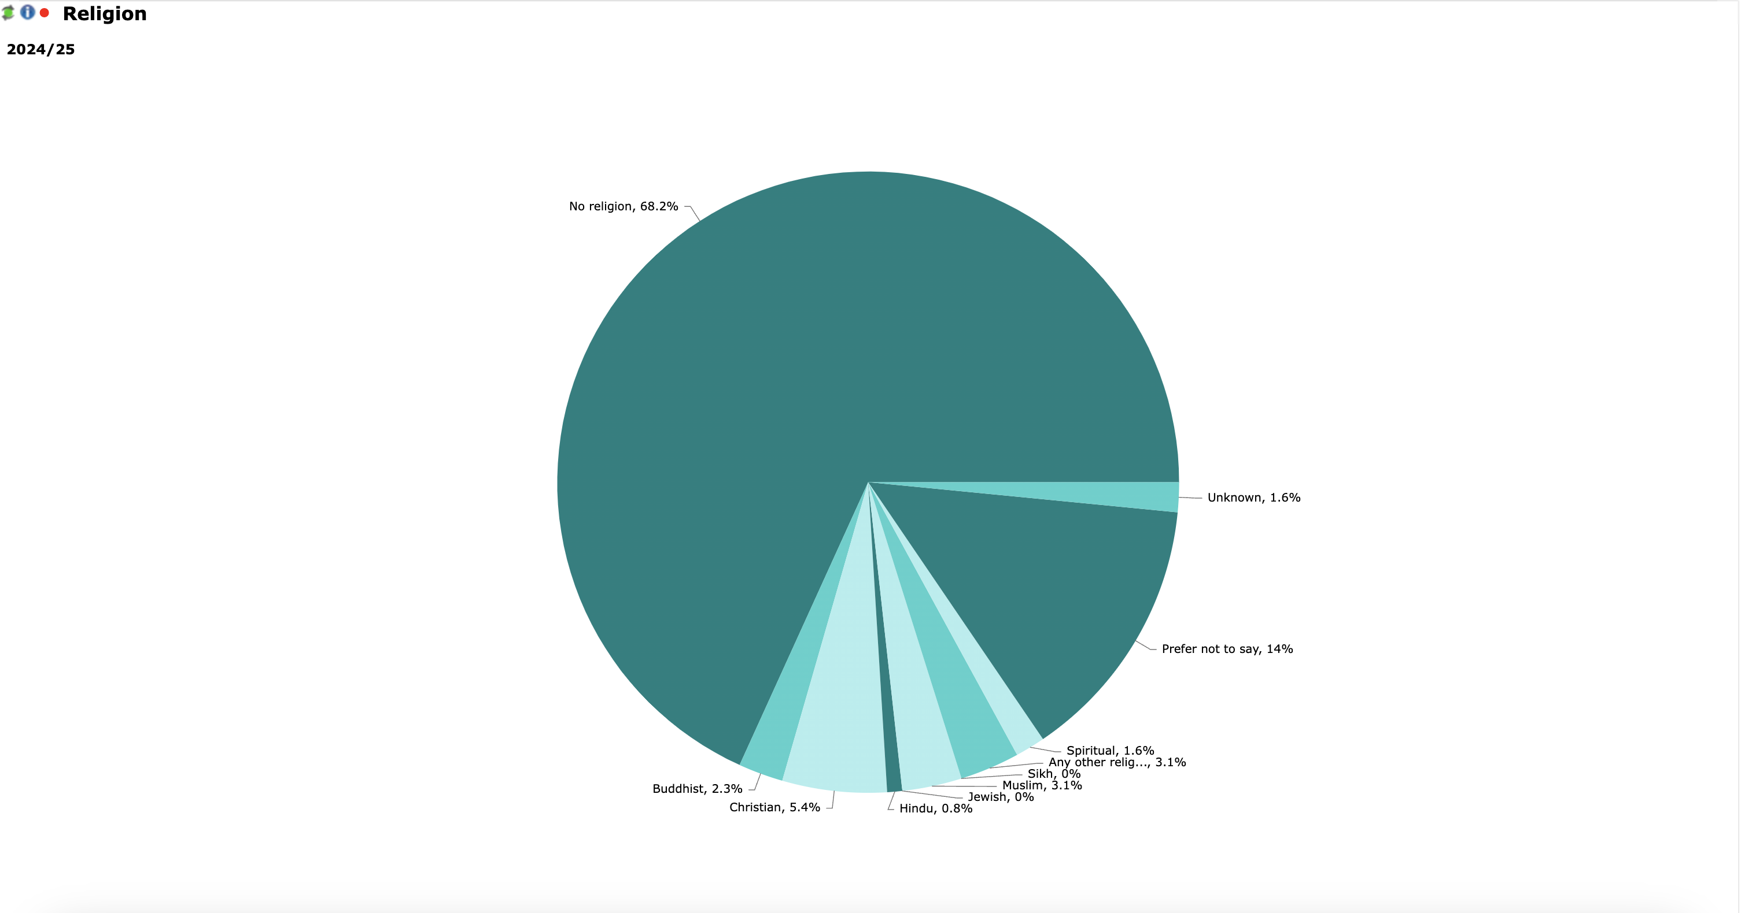

Disability:

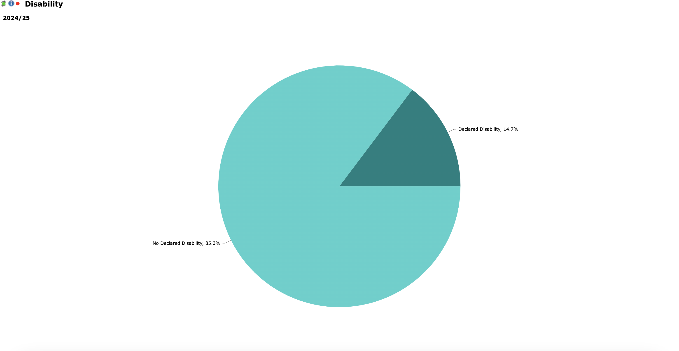

Ethnicity:

1. Research question borrowed and adapted from: Fauchon, Mireille (2024) *Illustration, Narrative and the Suffragette*, Bloomsbury Publishing  
   
2. I.e. Students will not need to share anything inherently personal about their identities/selfhood in order to engage with themes of individuality within the project if they do not wish to. In line this consideration, please see bibliography in the IP Unit of the PgCert blog, regarding the inherent risks that students can face in revealing selfhood and intersectional identites in the classroom, especially in the experience of students who are marginalised or embody protected characteristics, such as protected characteristics in race, religion, disability, gender, sexuality, and age:

   * Bradbury, Alice (2020) *A Critical Race Theory Framework for Education Policy Analysis: The Case of Bilingual Learners and Assessment Policy in England, Race Ethnicity and Education*, 23:2, 241-260, DOI: 10.1080/13613324.2019.1599338
   * Crenshaw, Kimberlé (1990) *Mapping the Margins: Intersectionality, Identity Politics, and Violence against Women of Color*. Stanford Law Review43 (6)
   * Eddo-Lodge, Reni (2017) Why I’m No Longer Talking To White People About Race, Bloomsbury Publishing
   * Garrett, Rhianna (2024) *Racism shapes careers: career trajectories and imagined futures of racialised minority PhDs in UK higher education, Globalisation, Societies and Education*, Routledge, DOI: 10.1080/14767724.2024.2307886
   * Gillborn, David (2008) Racism and Education: Coincidence or Conspiracy? Routledge Books
   * hooks, bell (2000) *Where We Stand: Class Matters*, Routledge Books
   * Jawad, H. (2022) Islam, Women and Sport: The Case of Visible Muslim Women. Available at: <https://blogs.lse.ac.uk/religionglobalsociety/2022/09/islam-women-and-sport-the-case-of-visible-muslim-women/> (Accessed: 23 July 2024)
   * Mouffe, Chantal (2008) Art and Democracy: Art as an Agnostic Intervention in Public Space, Open 2008 / No.14 / Art as a Public Issue, Available at: <https://readingpublicimage.wordpress.com/wp-content/uploads/2012/04/mouffe_open14_p6-151.pdf> (Accessed: 24 July 2024)
   * Phillips, Mike (1973) Black Teachers, Open Door, BBC Broadcasting. Available at: <https://www.bbc.co.uk/programmes/p06ctzhf> (Accessed 26 July 2024)
   * Rekis, Jaclyn (2023) *Religious Identity and Epistemic Injustice: An Intersectional Account.* Hypatia 38
   * Sadiq, Asif (2023) Diversity, Equity & Inclusion. Learning how to get it right, TEDx. Youtube, 2 March. Available at: <https://www.youtube.com/watch?v=HR4wz1b54hw>(Accessed: 26 July 2024)
   * Scandone, Berenice (2017) Social Class, Ethnicity and the Process of ‘Fitting In, Higher Education and Social Inequalities: University Admissions, Experiences, and Outcomes, edited by Richard Waller, Nichole Ingram, and Michael Ward, Routledge Books

  
3. ‘*I still remember the excitement I felt when I took my first class where a teacher wanted to change how we sat, where we […] could look at one another. That change forced us to recognise one another’s presence. We couldn’t sleepwalk our way to knowledge.’*

   hooks, b. (1994) *Teaching to Transgress: Education as the Practice of Freedom*, Routledge
4. *‘Between 3-30 Hertz (flashes per second) are the common rates to trigger seizures but this varies from person to person. While some people are sensitive at frequencies up to 60 Hertz, sensitivity under 3 Hertz is not common.’*

   Epilepsy Society, Available at: <https://epilepsysociety.org.uk/about-epilepsy/epileptic-seizures/seizure-triggers/photosensitive-epilepsy#:~:text=What%20rate%20of%20flashing%20light,3%20Hertz%20is%20not%20common>. [Last accessed January 2025]