Reflections on micro-teaching brief [blog post]

‘Interaction with artefacts deepens students’ learning.’ (Schultz 2012, p.185)

The micro-teaching brief page on our PGCert Moodle site is introduced by this quote. I love the word ‘artefact’ and have always found a deep curiosity within it.

Likely due to my own clumsiness, I have searched and searched the Moodle resources to find the full reference and source of this quote to no avail. A cursory look on ResearchGate suggests the Schultz here must be Katherine Schultz, who published three articles on education in 2012: one on silence in the classroom, one on new teachers, and one on shifting teacher practice to actively engage new immigrant students in urban classrooms.

Initial semiotic connotations of the word ‘artefact’ bring me, against my better judgement, to the idea of an object in a museum — or, more presciently, to an object originating from a place far, far away… in a museum. There are multiple issues around this association to the word. In a publication from the Research Center for Material Culture, titled Words Matter, anthropologist Wayne Modest is quoted:

“Paying attention to words means acknowledging that the language we use affects whether a person or a group feels excluded or included, whether they feel a sense of belonging to society. This is about representation, recognition and respect.”

I can’t help but wonder if the title Words Matter might have been inspired by bell hook’s incredible book, Where We Stand: Class Matters — which examines how ‘dilemmas’ of class and race are intertwined, and questions how the ‘fantasies of wealth’s power help keep the poor poor’. It is hard not to associate ‘the politics of greed’ with the acquisition of rare and precious artefacts, from colonised countries to the UK, at the centre of the UK’s museum collections. With the conscience swirling around these ideas, it might be productive to assume Schultz was quoted, above, in her article on shifting teacher practice to actively engage new immigrant students…

Traditionally, design objects encased and showcased in museums have provided a key resource for design undergraduates to learn about design and its related history and contexts. In many instances objects may be seen but not touched. Considering the international cohorts we work with at UAL, considering the [post-]colonial narrative on what we might consider worthy of the word ‘artefact’, and the rule of not touching — I believe it is essential to encourage a shift in our view of empowerment, towards individuality, and of course, towards an active inclusion of diversity and culture.

Documentation of micro-teaching

Context [outside of word-count]:

What better way to encourage active inclusion, than through an active teaching method, you ask?!

In Brian Eno’s lecture on the ecology of culture, he defines art as everything you don’t have to do:

“Now, what I mean by that is that there are certain things you do have to do to stay alive. You have to eat, for example. But you don’t have to invent Baked Alaska or sausage rolls or Heston Blumenthal. So, you have this basic activity that we and all other animals do, which is called eating, but then unlike all other animals, we do a lot of embroidery and embellishment on top of it. We make eating into a complicated, stylised activity of some kind. You have to wear clothes, but you don’t have to come up with Dior dresses or Doc Marten boots or the Chanel little black frock, or whatever it’s called. You can tell I haven’t got one. So once again we have an essential need — clothing ourselves — which we then do with an intense sort of interest.”

I like this idea, because it suggests that by making any decision that surpasses practicality in some way, an individual is capable of making an artistic statement. From the clothes we wear, to the objects we select for our bag in the morning, we are visual communicators.

Task in 500 words: Back-pack — Curator’s Tour

Following an example performed by myself, the participants were asked to ‘curate’ a selection of objects from their back-pack, and arrange these objects on a desktop within the studio space.

The task prompts the participants to question: What will it say about themselves as artists/designers if they are minimal in their selection of objects? What will it say about their identity as artists/designers if they pour the entire contents of their bag onto the desk, and arrange these objects in a precarious heap? How can they take advantage of these considerations when presenting the objects as ‘works’? What do these objects reveal about
their culture?

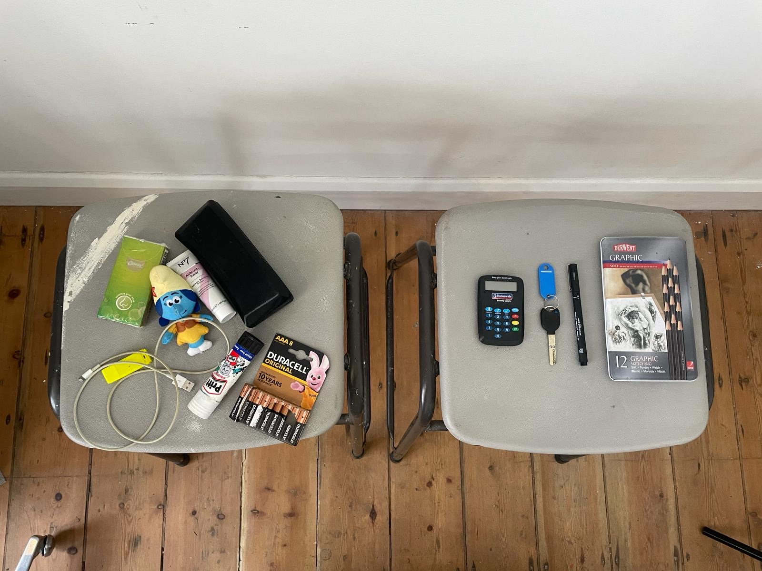
During the task, even the selection of the paint splattered stool[/plinth], next to the organisation and cleanliness of the stool that sits next to it, feel to me like a celebration of diversity

The participants were then asked to evaluate the deeper meaning of the installation they had each curated by giving a small explanation to the group. In the style of a Curator’s tour, the rest of the group were asked to respond as if they are guests at an exhibition — engaging with each speaker by making comments and asking further questions. This aspect of the task promotes participation and equality of opportunity, ensuring each member of the class gains a level of feedback. We moved onto the next speaker only when a question has been asked by another member of the class.

The task played out humourously in tone, and consisted of 75% of presentations describing a set of keys and a pair of headphones — which of course, didn’t entirely meet my ambition of bringing a diversity of culture and artefactual personal empowerment to the role of object-based learning in the classroom. However, it presented an opportunity to observe strengths, similarities and interests between the group as a whole, and [in some ways] acted as an abstract that shaped the group’s interactions with one another moving forward.

Feedback was positive and constructive, with room for improvement around timings especially (the task overran significantly, partly in a positive way [through enthusiastic engagement], but partly though my potentially unnecessary attempts to communicate the intentions of the task in too much detail). I am attempting to learn how to synthesise and clarify my enthusiasms when communicating with students, which is proving to be a challenge full of nuance, but one that I hope will aid my teaching in a big way. For now, I will leave you with some feedback from the micro-teaching session, which I was lucky enough to receive from, Miriam Sorrentino, a Senior Lecturer and Programme Leader in Media Studies:

“[We] shared narratives generated by personal items in a manner demonstrated by Eilis, this made us all comfortable quickly, there was a lot of laughter, and feedback was given immediately. This activity went on longer than had been planned but was responsive to [the participants’] engagement…”

“Eilis was able to critique her own session and discuss what worked well and what could have worked better […] We discussed the timing of the activities [as the plan had been overly ambitious] and [the importance of] building some flexibility into the timings. She was very sensitive to student engagement so extended the time given to activities as needed but this inevitably meant reducing time for other activities.”

References

- De La Puente, Gabrielle (2019) Why Museums Are Bad Vibes. The White Pube <https://thewhitepube.co.uk/art-thoughts/why-museums-are-bad-vibes/> Accessed April 2014
- Eno, Brian (2015) BBC Music John Peel Lecture <https://www.bbc.co.uk/sounds/play/p033smwp > Accessed April 2024
- Hardie, K. (2015). Wow: The Power of Objects In Object Based Learning and Teaching. <https://www.advance-he.ac.uk/knowledge-hub/wow-power-objects-object-based-learning-and-teaching> Accessed April 2024
- hooks, bell (2000), Where We Stand: Class Matters, Great Britain: Routledge
- Kolb, David (2015) Experiential Learning: Experience As The Source Of Learning And Development, Pearson Education, Incorporated
- Modest, Wayne (2018) Words Matter: An Unfinished Guide to Word Choices in the Cultural Sector. Tropen Museum, Afrika Museum, Museum Volkenkunde, Wereld Museum. p.17 <https://www.materialculture.nl/sites/default/files/2018-08/words_matter.pdf.pdf> Accessed April 2024
- Schultz, Katherine & Coleman-King, Chonika. (2012). Becoming Visible: Shifting Teacher Practice to Actively Engage New Immigrant Students in Urban Classrooms. The Urban Review. 44. 10.1007/s11256-012-0204-7.
- Schultz, Katherine & Ravitch, Sharon. (2012). Narratives of Learning to Teach. Journal of Teacher Education. 64. 35-46. 10.1177/0022487112458801.
- Schultz, Katherine. (2012). The Fullness of Silence in the Classroom. The Phi Delta Kappan. 94. 10.2307/41763607.
- Teicholz, Tom (2018) The British Museum: The Problematic Yet Enduring Appeal of Antiquities. Forbes <https://www.forbes.com/sites/tomteicholz/2018/10/14/the-british-museum-the-problematic-yet-enduring-appeal-of-antiquitie/?sh=1a022b7e4244> Accessed April 2024

BRIEF: Microteaching, Moodle <https://moodle.arts.ac.uk/mod/page/view.php?id=1152131> Accessed April 2024
Schultz, Katherine. (2012). The Fullness of Silence in the Classroom. The Phi Delta Kappan. 94. 10.2307/41763607.
Schultz, Katherine & Ravitch, Sharon. (2012). Narratives of Learning to Teach. Journal of Teacher Education. 64. 35-46. 10.1177/0022487112458801.
Schultz, Katherine & Coleman-King, Chonika. (2012). Becoming Visible: Shifting Teacher Practice to Actively Engage New Immigrant Students in Urban Classrooms. The Urban Review. 44. 10.1007/s11256-012-0204-7.
Teicholz, Tom (2018) The British Museum: The Problematic Yet Enduring Appeal of Antiquities. Forbes <https://www.forbes.com/sites/tomteicholz/2018/10/14/the-british-museum-the-problematic-yet-enduring-appeal-of-antiquitie/?sh=1a022b7e4244> Accessed April 2024
De La Puente, Gabrielle (2019) Why Museums Are Bad Vibes. The White Pube <https://thewhitepube.co.uk/art-thoughts/why-museums-are-bad-vibes/> Accessed April 2014
Modest, Wayne (2018) Words Matter: An Unfinished Guide to Word Choices in the Cultural Sector. Tropen Museum, Afrika Museum, Museum Volkenkunde, Wereld Museum. p.17 <https://www.materialculture.nl/sites/default/files/2018-08/words_matter.pdf.pdf> Accessed April 2024
hooks, bell (2000), Where We Stand: Class Matters, Great Britain: Routledge
Ibid. Chapter 5, p. 63.
Hardie, K. (2015). Wow: The Power of Objects In Object Based Learning and Teaching. <https://www.advance-he.ac.uk/knowledge-hub/wow-power-objects-object-based-learning-and-teaching> Accessed April 2024
Eno, Brian (2015) BBC Music John Peel Lecture <https://www.bbc.co.uk/sounds/play/p033smwp > Accessed April 2024
It is integral to the activity that this process of ‘curation’ is explicated carefully — especially when it comes to considering the social implications of emptying one’s back-pack for participants who might be less socially confident. This is also a way of highlighting to students the significance of their personalities in relation to their professional practice — do they rely on spoken word to explain their visual decision-making process, or will they prefer for the objects to speak for themselves? Could this affect the role they undertake in the design world?
The formal style of speaking, or, the Curator’s/guest’s style of speaking is intended as an opportunity to get even the shyest participants to present/offer feedback (as they can somewhat hide behind the language/role of a ‘curator’ or the performative pretentiousness [apologies] of an ‘institution’. Participants are prompted to speak about themselves in the 3rd person, as ‘the artist’, in order to separate their individuality from this mode of speaking [if they wish].
Utilising Kolb’s theory on converting experience into knowledge through four stages of learning: concrete experience, reflective observation, abstract conceptualisation, and active experimentation. Kolb, David (2015) Experiential Learning: Experience As The Source Of Learning And Development, Pearson Education, Incorporated
Headphones did in fact work as a cultural force of power, when a listener asked a speaker the question, “What was the last thing you listened to on your headphones?” and the answer was a song for peace. I was very glad of the question, and the answer — I was too distracted by the the form of the Bauhaus Universal Typeface ‘b’ in use, on Dr Dre’s Beats, to think beyond the object and the branding towards a more useful recognition of culture, in spite of commodification.
More on that in an upcoming blog post.

