The charismatic lecturer: part 1 [blog post]

In the first workshop we were given an extract from a Bruce MacFarlane book in the form of a photocopied piece of A4 paper. [Again…] Most likely in my own clumsiness, I have been unable to find the exact source of this extract, which was entitled ‘The charismatic lecturer’; but have enjoyed beginning to get to know a few other works from MacFarlane’s oeuvre in the process of trying to find out.

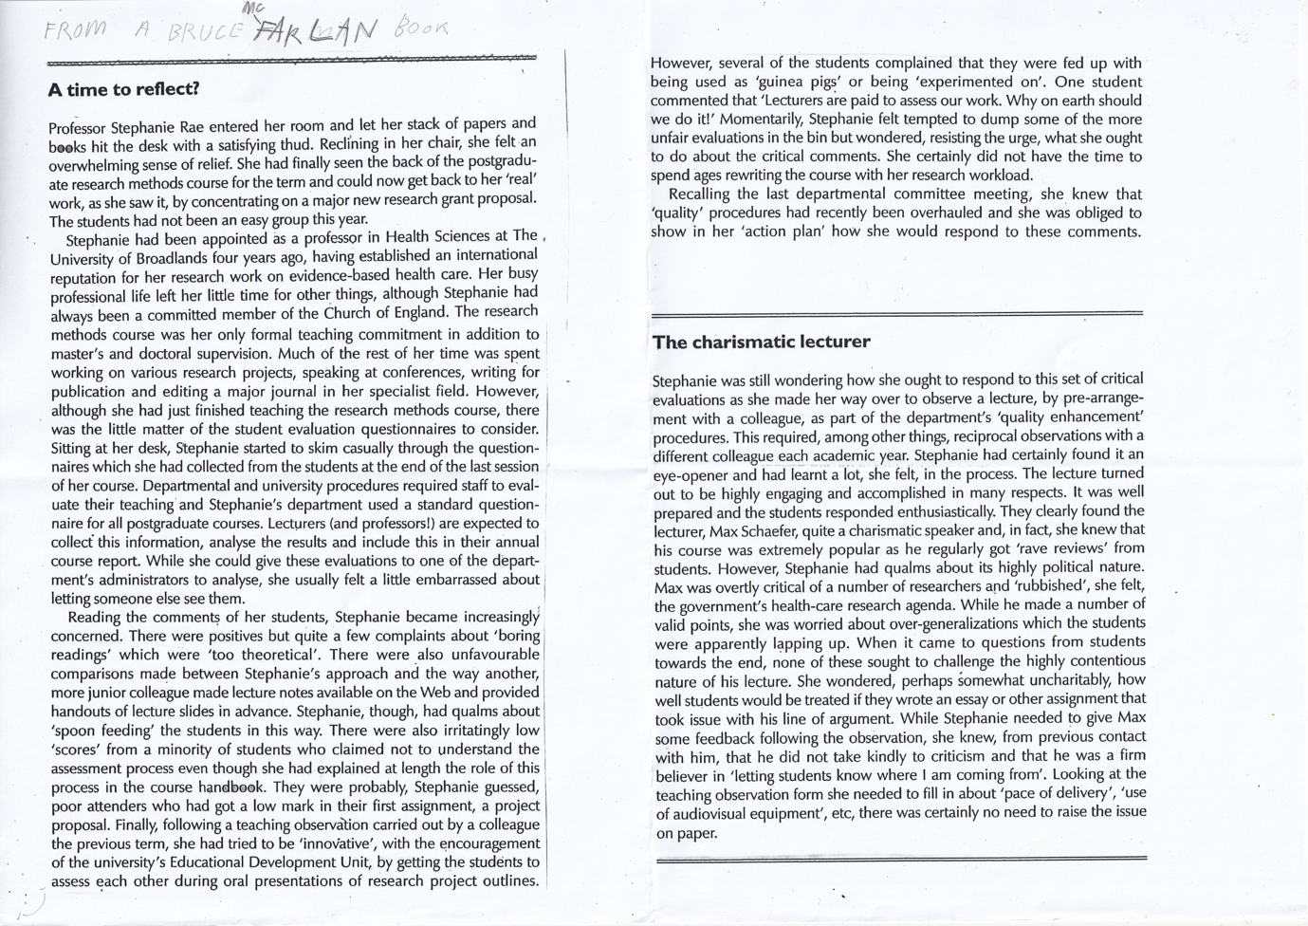

My interests are particularly piqued by Freedom to Learn, which is a book looking at the ‘hidden University curriculum’ of ‘compulsory attendance registers, class contribution grading, group project work and reflective learning exercises based on expectations of self-disclosure and confession’ that ‘take little account of the rights of students or individual differences between them’.

It is cited on the AdvancedHE profile page of Professor Bruce Macfarlane that he is currently working on a new book for Routledge, about the freedom to teach in Higher Education. One can only imagine that this new book might take the form of a similar critique of the overwhelming expectations within the Higher Education sector, and what new forms ‘academic freedom’ might take.

As of this September (2024), I will have been teaching in Higher Education for 10 years. Even in my relatively short time in the sector, I have witnessed a significant shift in expectations relating to planning and individuality — not just in relation to parity for the learners, but for the academics as well.

My first serious interest in teaching within higher education stemmed from my understanding of the film Educating Rita, by Willy Russell. Educating Rita is a two-hander play about a working-class woman who seeks Open University tuition and is assigned a disenchanted literature tutor called Frank. Each of the pair find delight in one another. They coin a somewhat symbiotic relationship. Whilst Frank teaches Rita about literature and academia, Rita too teaches Frank – to look at the world again with her freshness of perception. I attempted to write about this example of a teaching relationship in my MA thesis (2018), which was later edited and published through the Journal of Illustration (2023).
Due to the formality of both those documents, I didn’t feel brave enough to plainly say the following: In my opinion, the symbiotic nature of Frank and Rita’s relationship is largely made possible through Frank’s flaws and idiosyncrasies as a teacher — his openness, and his obvious faults, in some way, invite Rita to feel that she has something to offer him. This kind of relationship feels extremely contentious in relation to today’s expectations in the sector, not only due to shifting professional standards, but class sizes and contact-time too.

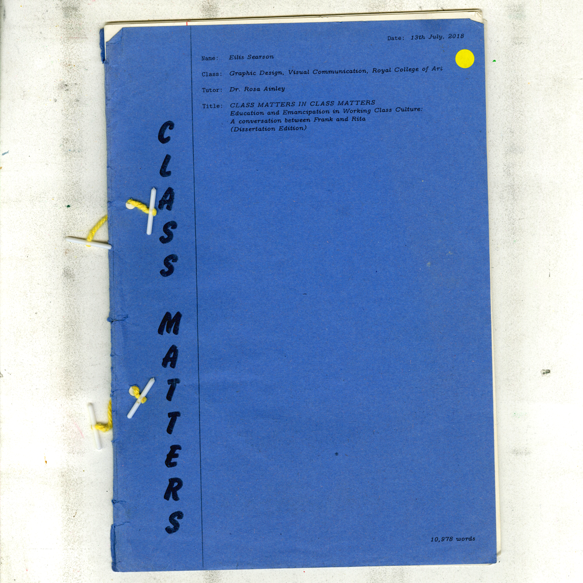

However, if we are to relate this idea back to the extract at hand, the charismatic lecturer, it is interesting to point out the risk involved in putting across a flaws (or in this case, over-generalisations) as an educator:

“When it came to questions from students towards the end, none of these sought to challenge the highly contentious nature of his lecture.”

This quote, describing concerns raised through a teaching observation where a lecturer made potentially problematic omittances in their session, illustrates that it might in fact take a special kind of learner (perhaps someone like Rita) to feel the confidence to challenge, or even reflect on, the teaching practice of the charismatic lecturer.

I find the nuances around this power dynamic very interesting. If I am totally honest with myself, I can’t deny that the idea of the charismatic lecturer is still something that I (as a learner) have found value in, especially in relation to my own freedom to learn outside of the bureaucracy of student expectations, which I have found to be somewhat oppressive. For want of a more intelligent phrasing, I find active authorship [including the flaws involved in this] easier to bounce off. I hope to understand what this taste as a learner means for me as a teacher throughout this course. I can already feel my fear receptors shivering — I don’t want to be sacked! Please, don’t sack me! I promise to follow the rules! I promise to follow the structure! I won’t be the charismatic lecturer! Or, or, or, is it possible to employ a both/and approach?!

References

- AdvanceHE (2024) Profile: Professor Bruce Macfarlane <https://www.advance-he.ac.uk/profile/professor-bruce-macfarlane> Accessed April 2024
- MacFarlane, Bruce (2023) Freedom to Learn: The threat to student academic freedom and why it needs to be reclaimed. Routledge
- Mcluhan, Marshall & Powers, Bruce (1989) The Global Village: Transformations in World Life and Media in the 21st Century. Oxford University Press
- Russell, Willy ([1980] 1991), Educating Rita, Second edition (ed. Longman Group Limited), England: Longman Literature.
- Searson, Eilis (2023) Class Matters in Class Matters: Education and Emancipation in Working Class Culture. Journal of Illustration: Intellect books

MacFarlane, Bruce (2023) Freedom to Learn: The threat to student academic freedom and why it needs to be reclaimed. Routledge <https://www.routledge.com/Freedom-to-Learn-The-threat-to-student-academic-freedom-and-why-it-needs-to-be-reclaimed/Macfarlane/p/book/9780415729161> Accessed April 2024
AdvanceHE (2024) Profile: Professor Bruce Macfarlane <https://www.advance-he.ac.uk/profile/professor-bruce-macfarlane> Accessed April 2024
Russell, Willy ([1980] 1991), Educating Rita, Second edition (ed. Longman Group Limited), England: Longman Literature.
Searson, Eilis (2023) Class Matters in Class Matters: Education and Emancipation in Working Class Culture. Journal of Illustration: Intellect books
MacFarlane, Bruce — source currently unknown, taken from a photocopied worksheet in workshop 1 of the PGCert, January 2024.
Here I use the term ‘freedom to learn’ in the understanding that has been offered to me through MacFarlane’s book, as previously cited in this blog post. MacFarlane, Bruce (2023) Freedom to Learn: The threat to student academic freedom and why it needs to be reclaimed. Routledge
In Marshall McLuhan’s last book The Global Village: Transformations in World Life and Media in the 21st Century (1989), he argues that we are moving from a Western ‘either-or’ approach to a ‘both-and’ approach that is more characteristic of non-Western cultures — with the ability to believe in two potentially contradictory things at once. Mcluhan, Marshall & Powers, Bruce (1989) The Global Village: Transformations in World Life and Media in the 21st Century. Oxford University Press

