The charismatic lecturer: part 2 [blog post]

In the book Performance Society, published by Booksfromthefuture, there is an essay by Merve Ünsal titled Artistic Research as a Form of Performance. The title of this essay is almost seductively self-explanatory, as for me, it highlights the individuality, subjectivity and performativity involved in understanding ‘art’ and ‘research’ as a subject.

“The word tuhaf in Turkish — translated as strange, weird, peculiar, funny, bizarre, in that order — is a word that a friend uses often to describe many things ranging from girls’ outfits to contemporary art to inappropriate behaviour. Thinking about this word, I wonder about specificity. Or rather, specificity in language, as I’m interested in the relationship between description and that which is described and how one can be both loyal and subjective. With loyalty, I’m referring to that relationship between the description and the described — perhaps, the gap between understanding, perception, created by the description and that which is described is exactly where the subjectivity of the speaker resides. In other words, what is the potentiality of subjectivity created by the very act of description?”

I like the idea that there is ‘potentiality’ in both understanding and misunderstanding.

When reading in support of my case studies for this unit, I encountered what felt like a more didactic view of the tutor/tutee dynamic; looking at the social learning theory of Albert Bandura, who proposed that learning takes place within social context through observation, imitation and modelling. Matt McClain’s research on ‘the demonstration’ takes this view into the design classroom:

“In Design, teacher modelling utilises the social interactions between teacher and learner to support increasing autonomy; with the intention that learners both know about (acquire) a process being demonstrated and are able to demonstrate (perform) that they know how to apply the knowledge.”
And yet, there’s that word perform again! There’s something about McClain’s choice, both grammatically (the brackets) and linguistically (not fully committing to the idea that the students are actually demonstrating knowledge — perhaps they are merely performing knowledge at this stage) that I find quite exciting and quite problematic at the same time.

Artists have been experimenting with performance lectures (as a sort of sub-genre of performance art) since the middle of the 20th century. Here’s a nice excerpt from a performance lecture script by John Cage (1959):

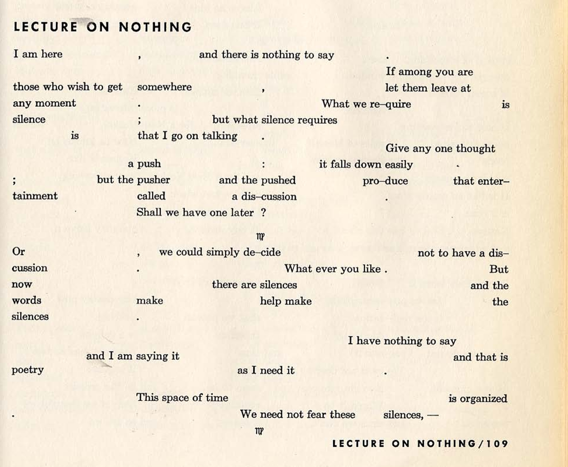
(Full text available at: <https://seansturm.files.wordpress.com/2012/09/john-cage-lecture-on-nothing.pdf> Accessed April 2024)

In Performance Society, there is an essay on the genre of performance lectures, by an artist called Jacob Rowlinson, that discusses the importance of making mistakes within the genre.

“For me, in embracing the performative, one is also actively encouraging moments of improvisation and spontaneous physical descision-making, which force the viewer (perhaps even more than with installations, multimedia video works, etc.) into drawing varied responses to the work. With this in mind, repeating a performance lecture is not to travel over the same territory or polish a hypothetically ‘perfect’ version, but to purposefully un-refine, destroy, refresh, omit, include, discover, and uncover for oneself what one is talking about.”

Of course, a performance lecture as an art form is rarely concerned with imparting wisdom or even creating an understanding in its listeners, unlike a lecture situated within the University. Even so, this quote reminds me of a moment within my own arts education which felt like an important one. Throughout my MA at the Royal College of Art, once a month I would attend a session called a ‘sound seminar’. The rules of this session were strict — nobody was allowed to talk, nobody was allowed to use their phones, and there was no reminder to get out a notebook a pen — the primary concern of these sessions was to listen, and to focus on ‘the listening eye’. The leader of the session (an academic) would play the participants music, from field recordings to pop songs, for three hours (as the room got dark). The most important rule of all, in my memory, was that nobody was allowed to dance.

Two years into my MA, approaching my last ever sound seminar, the academic had announced his retirement — so it turned out that my last ever sound seminar, might also be this academic’s last ever sound seminar too. The session played out as any other, and everybody stuck to the rules. The last song was announced. Getting Better by the Beatles. Considering that previous sound seminar song choices over my time at the RCA had included fast paced techno tracks, and classic dance music, what followed felt particularly unrelated to the musical content of the moment — nonetheless, a student, overtaken by emotion, stood up out of their seat and began to dance in the middle of the room. Everybody looked. The first second of this solitary action felt like it lasted a lifetime. But then, the academic stood up too, and started dancing himself. Suddenly the whole room was out of their seats, dancing in rapture.

From Barbara Ehenreich’s Dancing in the Street: A History of Collective Joy —
“The samba school danced down to the sand in perfect dignity, wrapped in their own rhythm, their faces both exhausted and shining with an almost religious kind of exultation. One thin, latte coloured young man dancing just behind the musicians set the pace. What was he in real life? A bank clerk? A bus boy? But here in his brilliant feathered costume he was a prince, a mythological figure. Maybe even a god. Here, for a moment, there were no divisions among people except for the playful ones created by Carnival itself. As they reached the boardwalk, bystanders started falling into the rhythm too and without any invitation or announcements, without embarrassment or even alcohol to dissolve the normal constraints of urban life, the samba school turned into a crowd and the crowd into a momentary festival. There was no point to it. No religious overtones, ideological message or money to be made. Just the chance, which we need much more of in this crowded planet, to acknowledge the miracle of our simultaneous existence with some sort of celebration.”

~

I should relate this back to the reading list.

The action of the aforementioned academic breaking his own rules through dancing, was to un-refine, destroy, refresh, omit, include, discover, and uncover for oneself what one is talking about.

But what is contained within the potentiality of this moment for the students? (Other than collective joy.) And is it possible to formally harness this potentiality?

I don’t have an answer. But, as laid out in my case studies, I am interested by the QAA Benchmarking statement for Art & Design when it states “In learning about the contextual setting of their discipline(s), students also engage with appropriate related theories within global, historical/contemporary and cultural/environmental settings, which inform that context and add purpose to their activity.” I wonder if there might be empowerment in including the history of arts education, or of higher education itself, within the (s) of our discipline(s) — in an attempt to prepare our students not just to understand the idea of the charismatic lecturer, but to reflect, to challenge, to perform, to demonstrate, or to change it.

Could unpacking this knowledge with our students, and together embracing its omittances, also offer academics a wider freedom to teach?

References

- AdvanceHE (2024) Profile: Professor Bruce Macfarlane <https://www.advance-he.ac.uk/profile/professor-bruce-macfarlane> Accessed April 2024
- Bandura, Albert (1977). Social learning theory. New Jersey: Prentice Hall.
- Cage, John (1959) Lecture on Nothing. Incontri Musicali. <https://seansturm.files.wordpress.com/2012/09/john-cage-lecture-on-nothing.pdf> Accessed April 2024
- Ehenreich, Barabara (2007) Dancing in the Street: A History of Collective Joy. MacMillan Publishing: Holt Paperbacks.
- Kennedy, G & Welch, E (2019) QAA Subject Benchmarking Statement – Art and Design. p.6. <https://www.qaa.ac.uk/docs/qaa/subject-benchmark-statements/sbs-art-and-design-17.pdf?sfvrsn=71eef781_16> Accessed April 2024
- Martinez, Yves & Trees, Joshua (2017) Performance Society. Booksfromthefuture
- McLain, Matt (2021) Developing perspectives on ‘the demonstration’ as a signature pedagogy in design and technology education, Int J Technology Design Education 31, p. 3–26
- Rowlinson, Jacob (2017) Performance Society. Booksfromthefuture p.93
- Ünsal, Merve (2017) Performance Society. Booksfromthefuture P.203

Martinez, Yves & Trees, Joshua (2017) Performance Society. Booksfromthefuture
Ibid. Ünsal, Merve (2017) Performance Society. Booksfromthefuture P.203
Bandura, Albert (1977). Social learning theory. New Jersey: Prentice Hall.
McLain, Matt (2021) Developing perspectives on ‘the demonstration’ as a signature pedagogy in design and technology education, Int J Technology Design Education 31, p. 3–26
Cage, John (1959) Lecture on Nothing. Incontri Musicali. <https://seansturm.files.wordpress.com/2012/09/john-cage-lecture-on-nothing.pdf> Accessed April 2024
Martinez, Y. & Trees, J. (2017) Performance Society. Booksfromthefuture
Rowlinson, Jacob (2017) Performance Society. Booksfromthefuture p.93
Ehenreich, Barabara (2007) Dancing in the Street: A History of Collective Joy. MacMillan Publishing: Holt Paperbacks.
Rowlinson, Jacob (2017) Performance Society. Booksfromthefuture p.93
Kennedy, G & Welch, E (2019) QAA Subject Benchmarking Statement – Art and Design. p.6. <https://www.qaa.ac.uk/docs/qaa/subject-benchmark-statements/sbs-art-and-design-17.pdf?sfvrsn=71eef781_16> Accessed April 2024
AdvanceHE (2024) Profile: Professor Bruce Macfarlane <https://www.advance-he.ac.uk/profile/professor-bruce-macfarlane> Accessed April 2024

